Lab 8 - Configure Basic IPv6 Connectivity
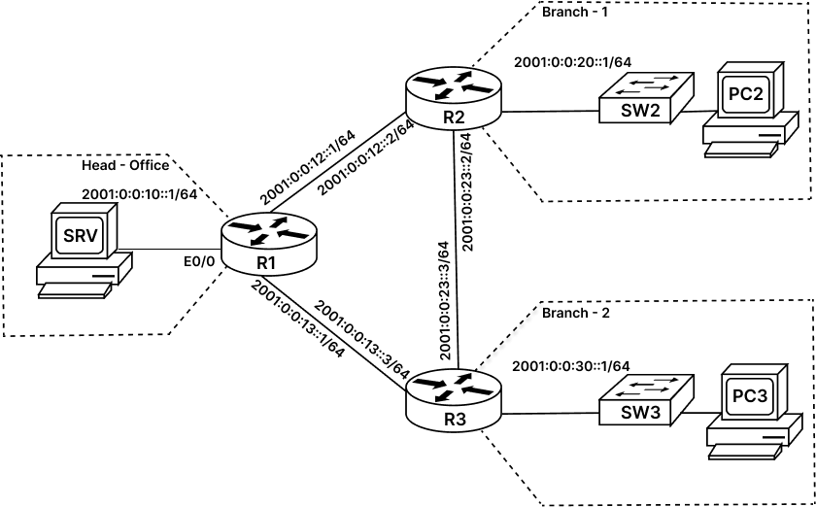

Task 1: Configure IPv6 Addresses on Branch Routers:
In this task, we will configure IPv6 addresses on all relevant Interface of each branch router (R2, R3) and Head-office router (R1).
LAN Equipment’s like Switches (SW2 and SW3) and all branch computers (PC-02 and PC-03) are pre-configured with IPv6 addresses, default-gateways, usernames, passwords, and all other configurations.
Step 1: Access the console of Head-office router R1 and enter interface config mode to configure IPv6 addresses as seen in diagram. Use the following command:
Note: Password for privilege EXEC mode is 'cisco'
R1> enable
R1# config terminal
R1(config)# ipv6 unicast-routing
R1(config)# interface ethernet0/0
R1(config-if)# ipv6 address 2001:0:0:10::1/64
R1(config-if)# no shutdown
R1(config-if)# exit
R1(config)# interface serial1/2
R1(config-if)# ipv6 address 2001:0:0:12::1/64
R1(config-if)# no shutdown
R1(config-if)# exit
R1(config)# interface serial1/3
R1(config-if)# ipv6 address 2001:0:0:13::1/64
R1(config-if)# no shutdown
R1(config-if)# end
R1#
Step 2: Access the console of R2 Branch-1 router and enter interface config mode to configure IPv6 addresses as seen in diagram. Use the following command:
Note: Password for privilege EXEC mode is 'cisco'
R2> enable
R2# config terminal
R2(config)# ipv6 unicast-routing
R2(config)# interface ethernet0/0
R2(config-if)# ipv6 address 2001:0:0:20::1/64
R2(config-if)# no shutdown
R2(config-if)# exit
R2(config)# interface serial1/2
R2(config-if)# ipv6 address 2001:0:0:12::2/64
R2(config-if)# no shutdown
R2(config-if)# exit
R2(config)# interface serial1/0
R2(config-if)# ipv6 address 2001:0:0:23::2/64
R2(config-if)# no shutdown
R2(config-if)# end
R2#
Step 3: Access the console of R3 Branch-2 router and enter interface config mode to configure IPv6 addresses as seen in diagram. Use the following command:
Note: Password for privilege EXEC mode is 'cisco'
R3> enable
R3# config terminal
R3(config)# ipv6 unicast-routing
R3(config)# interface ethernet0/0
R3(config-if)# ipv6 address 2001:0:0:30::1/64
R3(config-if)# no shutdown
R3(config-if)# exit
R3(config)# interface serial1/3
R3(config-if)# ipv6 address 2001:0:0:13::3/64
R3(config-if)# no shutdown
R3(config-if)# exit
R3(config)# interface serial1/0
R3(config-if)# ipv6 address 2001:0:0:23::3/64
R3(config-if)# no shutdown
R3(config-if)# end
R3#
Task 2: Verify Configuration:
Step 1: Access the console of R1 router and enter the Privilege EXEC mode. Verify the IPv6 configuration and connectivity by using following command:
R1# show ipv6 interface brief

Ethernet0/0 [up/up]
FE80::A8BB:CCFF:FE00:100
2001:0:0:10::1
Serial1/2 [up/up]
FE80::A8BB:CCFF:FE00:100
2001:0:0:12::1
Serial1/3 [up/up]
FE80::A8BB:CCFF:FE00:100
2001:0:0:13::1

R1# ping 2001:0:0:12::2
Type escape sequence to abort.
Sending 5, 100-byte ICMP Echos to 2001:0:0:12::2, timeout is 2 seconds:
!!!!!
Success rate is 100 percent (5/5), round-trip min/avg/max = 8/8/9 ms

R1# ping 2001:0:0:13::3
Type escape sequence to abort.
Sending 5, 100-byte ICMP Echos to 2001:0:0:13::3, timeout is 2 seconds:
!!!!!
Success rate is 100 percent (5/5), round-trip min/avg/max = 8/8/9 ms
Step 2: Access the console of R2 router and enter the Privilege EXEC mode. Verify the IPv6 configuration and connectivity by using following command:
R2# show ipv6 interface brief

Ethernet0/0 [up/up]
FE80::A8BB:CCFF:FE00:200
2001:0:0:20::1
Serial1/0 [up/up]
FE80::A8BB:CCFF:FE00:200
2001:0:0:23::2
Serial1/2 [up/up]
FE80::A8BB:CCFF:FE00:200
2001:0:0:12::2

R2# ping 2001:0:0:12::1
Type escape sequence to abort.
Sending 5, 100-byte ICMP Echos to 2001:0:0:12::1, timeout is 2 seconds:
!!!!!
Success rate is 100 percent (5/5), round-trip min/avg/max = 8/8/9 ms

R2# ping 2001:0:0:23::3
Type escape sequence to abort.
Sending 5, 100-byte ICMP Echos to 2001:0:0:23::2, timeout is 2 seconds:
!!!!!
Success rate is 100 percent (5/5), round-trip min/avg/max = 4/4/5 ms

R2# ping 2001:0:0:20::10
Type escape sequence to abort.
Sending 5, 100-byte ICMP Echos to 2001:0:0:20::10, timeout is 2 seconds:
!!!!!
Success rate is 100 percent (5/5), round-trip min/avg/max = 1/1/1 ms
Step 3: Access the console of R1 router and enter the Privilege EXEC mode. Verify the IPv4 configuration using following command:
R3# show ipv6 interface brief

Ethernet0/0 [up/up]
FE80::A8BB:CCFF:FE00:300
2001:0:0:30::1
Serial1/0 [up/up]
FE80::A8BB:CCFF:FE00:300
2001:0:0:23::3
Serial1/3 [up/up]
FE80::A8BB:CCFF:FE00:300
2001:0:0:13::3

R3# ping 2001:0:0:13::1
Type escape sequence to abort.
Sending 5, 100-byte ICMP Echos to 2001:0:0:13::1, timeout is 2 seconds:
!!!!!
Success rate is 100 percent (5/5), round-trip min/avg/max = 8/8/9 ms

R3# ping 2001:0:0:23::2
Type escape sequence to abort.
Sending 5, 100-byte ICMP Echos to 2001:0:0:23::2, timeout is 2 seconds:
!!!!!
Success rate is 100 percent (5/5), round-trip min/avg/max = 8/8/9 ms

R3# ping 2001:0:0:30::10
Type escape sequence to abort.
Sending 5, 100-byte ICMP Echos to 2001:0:0:30::10, timeout is 2 seconds:
!!!!!
Success rate is 100 percent (5/5), round-trip min/avg/max = 4/7/21 ms
Task 3: Configure IPv6 Stateless Autoconfiguration:
IPv6 Stateless Autoconfiguration: Nodes can automatically configure global IPv6 addresses without the need for DHCP server or manual configuration.
Router advertises network prefixes in Router Advertisement (RA) messages, and its willingness to function as a default gateway for the link. RA messages are sent periodically and in response to neighbor solicitation messages.
A device can automatically configure global IPv6 addresses by appending its interface identifier (64 bits) to the prefixes (64 bits) included in the RA messages. The resulting 128-bit IPv6 addresses configured by the node are then subjected to duplicate address detection to ensure their uniqueness on the link. If the prefixes advertised in the RA messages are globally unique, then the IPv6 addresses configured by the node are also guaranteed to be globally unique.
Note: All interfaces on IPv6 nodes must have a link-local address, which is usually automatically configured from the identifier for an interface and the link-local prefix FE80::/10. A link-local address enables a node to communicate with other nodes on the link and can be used to further configure the node.
On SRV (server), let us configure Ethernet0/0 to use stateless autoconfiguration for the IPv6 address assignment and for the IPv6 default route assignment.
Step 1: Access the Command Line Interface (CLI) mode of SRV Server by using ‘x’ option from the menu. Type ‘root’ on prompt and use password as cisco:
**************************************************************************
**************************************************************************
** Welcome to Server MENU **
** **
** Press 1 --> show ipv6 interface brief (Ethernet 0/0) **
** **
** Press 2 --> show ipv6 route **
** **
** Press 3 --> To Ping 2001:0:0:10::1 (R1 - Gateway Router) **
** **
** Press 4 --> To Ping 2001:0:0:12::2 (R2 - Branch-1 Router) **
** **
** Press 5 --> To Ping 2001:0:0:13::3 (R3 - Branch-2 Router) **
** **
** Press x --> To Open CLI mode (Command Line Interface) **
** **
** Press q --> To exit the device **
**************************************************************************
**************************************************************************

x

SRV> root
Password: cisco

SRV#
Step 1: In the CLI mode of SRV Server type configure the following command:
SRV# configure terminal
SRV(config)# interface Ethernet0/0
SRV(config-if)# ipv6 address autoconfig default
SRV(config-if)# end
Step 2: Verify the IPv6 configuration and connectivity by using following command:
SRV# show ipv6 int brief

Ethernet0/0 [up/up]
FE80::A8BB:CCFF:FE00:400
2001::10:A8BB:CCFF:FE00:400

SRV# show ipv6 route
IPv6 Routing Table - default - 4 entries
Codes: C - Connected, L - Local, S - Static, U - Per-user Static route
B - BGP, HA - Home Agent, MR - Mobile Router, R - RIP
H - NHRP, I1 - ISIS L1, I2 - ISIS L2, IA - ISIS interarea
IS - ISIS summary, D - EIGRP, EX - EIGRP external, NM - NEMO
ND - ND Default, NDp - ND Prefix, DCE - Destination, NDr - Redirect
O - OSPF Intra, OI - OSPF Inter, OE1 - OSPF ext 1, OE2 - OSPF ext 2
ON1 - OSPF NSSA ext 1, ON2 - OSPF NSSA ext 2, l - LISP
ND ::/0 [2/0]
via FE80::A8BB:CCFF:FE00:100, Ethernet0/0
NDp 2001:0:0:10::/64 [2/0]
via Ethernet0/0, directly connected
L 2001::10:A8BB:CCFF:FE00:400/128 [0/0]
via Ethernet0/0, receive
L FF00::/8 [0/0]
via Null0, receive
SRV#
The default route (to prefix ::/0) is pointing to the R1 link-local address. The ND code indicates that this default route was learned as part of the neighbor discovery (ND) process.
The NDp entry describes the prefix that was learnt from R1 router RA advertisement message.
Step 3: Verify the connectivity by using ping command as seen below:
From SRV we should be able to ping the R1 routers global unicast addresses 2001:0:0::10::1 of Ethernet0/0 interface, 2001:0:0::12::1 of Serial1/2 and 2001:0:0:13::1 of Serial1/3. Confirm this connectivity using the ping command
SRV# ping 2001:0:0:10::1
Type escape sequence to abort.
Sending 5, 100-byte ICMP Echos to 2001:0:0:10::1, timeout is 2 seconds:
!!!!!
Success rate is 100 percent (5/5), round-trip min/avg/max = 4/7/22 ms

SRV# ping 2001:0:0:12::1
Type escape sequence to abort.
Sending 5, 100-byte ICMP Echos to 2001:0:0:12::1, timeout is 2 seconds:
!!!!!
Success rate is 100 percent (5/5), round-trip min/avg/max = 1/1/1 ms

SRV# ping 2001:0:0:13::1
Type escape sequence to abort.
Sending 5, 100-byte ICMP Echos to 2001:0:0:13::1, timeout is 2 seconds:
!!!!!
Success rate is 100 percent (5/5), round-trip min/avg/max = 1/1/1 ms
Step 4: Change the IPv6 address of server (SRV) manually to 2001:0:0::10::10/64 for further labs. use command as seen below:
SRV(config)# interface ethernet0/0
SRV(config-if)# ipv6 address 2001:0:0:10::10/64
SRV(config-if)# no shutdown
SRV(config-if)# exit
SRV(config)# ipv6 route ::/0 ethernet 0/0

